Preview Activity Lesson 14

1. Imagine that you are moving into the neighborhood shown below. Which backyard would you choose? Why? **The backyard I would choose is the one with the basketball hoop. I would choose it because I love playing basketball and I could play with my friends and brother with it.**

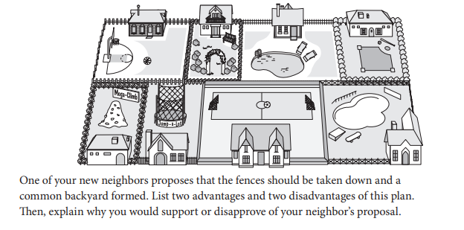

1. Advantages: You get too many activities from it if the neighbors allow it and you could get to know your neighbors and talk to them.
2. Disadvantages: No Privacy and people might be annoyed with people using their yard to play in it and trespassing would also annoy them.
3. I support/disapprove (disapprove) of this proposal becauseI like my privacy and fences make me feel safe so no one would use my yard or break into it. Fences protect you plus it could help you keep out wild animals.